HON 3253: Trailblazing the National Parks
Study Abroad Course Application
July/Aug 2027
updated 08-30-2026

We are excited for you to consider this study abroad course offered by the UTSA Honors College (HC)!
- Attend one of the Zoom information sessions for more details and to ask questions.
- Applicants must be currently accepted into the Honors College and be graduating in Fall 2027 or later.
- Be in Good Academic Standing and show good faith to remain in this manner as the school year completes.
- Applications + final Fall 2026 transcripts + 20-minute Zoom interviews will be given in late winter 2026/early Spring 2027 until slots are filled. If it is VERY likely you want to take this course, submit intent as early as possible.
- New for 2027: You MUST apply for the Experiential Learning Award(ELA) in the Scholarship Hub as part of your HON 3253 application process as it may be possible to reduce your costs regardless of financial status. Be sure to note which date you submit your ELA application. The awards committee meets only once each month to review applications. If an ELA is granted (the process can take several months), you can receive up to $750 award that gets deposited into your student account to help pay tuition and fees.
  - HINT: Use your own words (not AI) and create a hypothetical budget (e.g., passport, laundry, gear, course fees, food) for how the award might be used. Questions regarding ELA? Contact Stacie Garza, HC Fiscal Specialist.
  - 30 Day eligibility notice: Once a student who has applied for the ELA hears back from the scholarship committee that they have been granted an award, they must respond via email to accept the award offer or communicate with the Honors College Financial Unit to decline the award within 30 days of the award being offered. If no action or communication is received within that 30-day period, the student will be deemed ineligible, and the award offer will be withdrawn. Remember this is up to $750 award money into your account to help with tuition regardless of financial situation! Check your email regularly and respond in a timely manner.
- Students are held to the Student Code of Conduct that is critical in demonstrating appropriate behavior. Violations and alleged violations under investigation in Fall 2026/Spring 2027 will be discussed with the Behavior Intervention Team for assessing whether a prospective participant should remove themself from course consideration.
- If you have any questions, please email Dr. Karen Engates.
INSTRUCTIONS:
- Download this document. Do not delete anything except where indicated. Read all information and type answers in red font. Do not submit your application + transcript until final Fall 2026 grades have been posted in MyUTSA account (after Dec 15). Incomplete or late applications will not be considered.
- Save document as a PDF with your first and last name (e.g., KarenEngatesHON3253app2027.pdf).
- Do NOT use AI to generate answers. We want to hear your voice. Respect word limits requested.
- Submit completed application + final fall 2026 transcript in one email to: karen.engates@utsa.edu
- Review important dates, as some of them have a very quick turnaround time.
- Once documents have been received, you will be contacted within ~24 hours to schedule a 20-minute Zoom interview in the next few days. Check email regularly to respond.
- All students will receive a status notification email. Up to (10) students will be accepted, and a waiting list will be generated. Students who formally accept will need to pay a $750 Trailblazing program payment to their student account no later than the date specified (e.g., Jan 15, 2027) or they will be removed from the list, and the next person will be notified.
COST:
Due to generous HC funding, we can offer the trip part of this course at a much-reduced cost compared to an individual on vacation in this highly popular area for summer travel. Cost of tuition and fees varies depending on your situation:
- (3)-hr summer tuition + fees for an in-state Texas resident costs ~$1700 (based on 2026 pricing).
  - Top/Terry/Leadership/programs may assist with these costs. Contact Honors advisor and Fiscal Services.
  - Study Abroad Office has previously refunded some fees (e.g., recreation center, library, computer labs) after the course has ended but this is not a guarantee and will be determined later.
  - HC pays the study abroad international program fee and international insurance for each participant (~$250).
  - Students need to show at least 25% of tuition & fees payment by mid-May to indicate continued interest and 100% payment by the course start date (July 6). This is a different timeline than other UTSA summer courses.
- $750 Trailblazing program fee (separate from tuition and fees) to help cover activities, lodging, plane fares, etc.
- Meals are not included. Plan for simple DYI meals for early starts, day hiking, and cabin dinners (11 days).
- Required: hiking boots that cover your ankles (not trail shoes).
- Passport book (~$160+ if you do not have one) that expires Jan 28, 2028, or later. If there is an emergency and we need to fly home from Canada, a passport card is not valid for international flights.
- Laundry (~$10), souvenirs ($?).

IMPORTANT DATES
Zoom Info Sessions (repeats info) | Wed, Sept 16, 2026, 12:00-12:30 PM CT https://utsa.zoom.us/j/91455800239  Wed, Oct 14, 2026, 12:00-12:30 PM CT https://utsa.zoom.us/j/98675723095  Wed, Nov 18, 2026, 12:00-12:30 PM CT https://utsa.zoom.us/j/98551265198
Oct 1, 2026 - Dec 15, 2026 | - Start working on Trailblazing Application (Word doc) so you have enough time to ask questions before the submission window opens.  - Required: Apply for Experiential Learning Award (up to $750) in Scholarship Hub. It is possible to apply for this award w/o knowing your acceptance into this course as the committee reviews these only once a month. It takes 1-4 months to be reviewed and potentially awarded.
Dec 15 to Dec 31, 2026 | Submit completed application + Fall 2026 final grades transcript to Dr. Engates.  Final grades for transcript should be available Dec 15 by 5PM in MyUTSA.
Dec 16 to Dec 31, 2026  (No interviews Dec 24-Dec 25) | 20-minute required Zoom interviews – May occur as quickly as within 24 hours of submitted documents. Check your email.
By Jan 1, 2027 | Status notification (may occur earlier): accepted, waitlisted, denied.
By Jan 8, 2027 @ 5PM CT | Accepted students must declare intent to take the course (yes, no) via email to Dr. Engates. If no response is received by Jan 8, your name will be dropped from the list and someone on the waitlist will be contacted. For those that indicate YES, a $750 program fee will be posted to your account.
ACCEPTED STUDENTS MUST REGULARLY CHECK THEIR EMAILS AS THEY WILL RECEIVE MESSAGES THAT INCLUDE ACTION ITEMS TO COMPLETE WITH DEADLINES.
By Jan 15, 2027 @ 5PM CT | Send a screenshot of your payment to Dr. Engates no later than Friday, January 15, by 5PM CT, to show continued interest in this course.
Jan 16 – Feb 19, 2027*  *may change per office deadlines.* | ACCEPTED students must complete additional electronic paperwork for the UTSA study abroad portal no later than Friday, February 19, by 5 PM CT.
First week of Feb 2027 (TBD: Feb 2) | Mandatory Zoom meeting for introductions and information on how to complete the Study Abroad Portal. Time TBD (e.g., 7-8PM).
mid-March 2027 (TBD) | HC will register students for HON 3253 during registration. Study Abroad Office will also have a mandatory online pre-orientation meeting (~90 minutes, several dates and times in Mar/Apr will be posted).
First week of May 2027 (TBD: May 4) | Mandatory on-campus meeting. Time TBD (e.g., 6:30-8:00PM).
By Fri, May 14, 2027 @ 5PM CT | Students must show screenshot payment of at least $250 toward summer tuition and fees by 5PM CT to Dr. Engates to show continued interest. It is advisable to complete 100% payment of tuition and fees ASAP.
Tue, July 6, 2027 | Mandatory Zoom class meeting #1 (6:30PM-8:00PM CT)
Tue, July 13, 2027 | Mandatory Zoom class meeting #2 (6:30PM-8:00PM CT)
Tue, July 20, 2027 | Mandatory Zoom class meeting #3 (6:30PM-8:00PM CT)
Sat, July 24, 2027 | Mandatory IN PERSON meeting #4 (10:00AM-2:00PM CT)
Tue, July 27, 2027 | Depart SAT to Montana (time TBD)
Fri, Aug 6, 2027 | Arrive SAT (time TBD)
Answer in RED FONT in spaces provided.
- Provide information requested.
  - Name (first/last/preferred): [insert answer]
  - Name as it would exactly appear on your passport for a plane ticket (errors may cause you to be ineligible to fly): [insert: first middle last]
  - Date of birth (MM/DD/YYYY): [insert answer]
  - Gender (for airline ticketing and cabin configurations): [insert answer]
  - Abc123 and Banner ID: [insert answer]
  - Major(s): [insert answer]
  - Expected graduation date (semester, year): [insert answer]
  - UTSA email: [insert answer]
  - Best phone number to contact you: [insert answer]
  - Your summer 2027 mailing address: [insert answer]
  - Emergency contact: First/last name, phone number, relationship to you [insert answer]
  - What date did you submit your ELA application to Scholarship Hub? [insert answer]
  - Fitness level (1=sedentary up to 10=active 5+/wk): [insert answer]
  - Swimming ability (1=cannot swim up to 10=swims daily/lifeguard): [insert answer]
  - What is the farthest distance you have ever hiked, where was it, and when? [insert answer]
  - What is the highest altitude you have ever experienced not being in an airplane? [insert answer]
  - Do you experience (not dealbreakers): Car/motion/air sickness: [Y,N], Aversion to heights: [Y,N], Altitude sickness: [Y,N]
    - If you answered YES to any, what is your method to handle the situation(s)? [insert answer]
  - Date of last tetanus shot (MM/DD/XXXX): [insert answer]
  - When was the last time you flew on an airplane? [insert answer (Y,N)]
  - Have you ever completed another study away/study abroad college course? [insert answer (Y,N)]
  - Did you ever attend summer camp (e.g., at least seven days away)? [insert answer (Y,N)]
  - Do you have a current passport? [insert answer (Y,N)]
    - If Y, insert a screenshot of your passport page with no glare. [insert answer]
      - If your passport expires before Jan 28, 2028, you will need to show evidence of submitted new passport application by end of February 2027 to ensure your passport will arrive before course registration begins in mid-March 2027.
    - If N, review travel.state.gov for passport application information. If selected, you will need to show evidence of submitted new passport application by end of January 2027 to A) allow you to post information in the study abroad portal and B) ensure your passport will arrive before course registration begins in mid-March 2027.
  - Airline information:
    - American Airlines frequent flyer #: [insert answer or type N/A]
    - United Airlines frequent flyer #: [insert answer or type N/A]
    - Delta Airlines frequent flyer #: [insert answer or type N/A]
    - TSA precheck #: [insert answer or type N/A]
    - Passenger Redress #: [insert answer or type N/A]
  - UTSA has insurance requirements for students traveling internationally and within the USA. These will be further explained once you are accepted. You should be prepared to pay out of pocket if insurance does not cover your needs. Do you understand and have a way to cover additional costs? [insert answer (Y,N)]

- This program is for students interested in experiencing an alternative way of living that lacks amenities of urban commercial life, including limitations on technology where you might not have use of your phone most of the day or at all some days. Being prepared and on time to meetings and activities is essential for this type of group experience, so tardiness/absences will not be tolerated. Shared lodging is modest, and climates range hot to cold. Food is planned, purchased, and prepared by the individual participant. Cell phone use is extremely limited, not an everyday luxury. Minimalization, organization, and flexibility in body/mind/attitude are core to this type of outdoor experience. Daily expectations: early morning starts, some long drives; physical exertion; discussions; journaling; providing your own meals; adapting to others; maintaining personal hygiene; fully participating in activities and promoting a positive experience for everyone. Students should be able to hike most days (5-8+ miles daily, with longest hike ~12 miles) at moderate inclines and prepare best as possible for higher elevations (up to 8000’). We will live humbly and closely as a group in cabins and Airbnb’s and within the larger public community at campgrounds with other visitors, and wildlife, including bugs, birds, snakes, spiders, racoons, bears, etc. Participants must be able to attend all course meetings in their entirety unless there is an extreme emergency as they are each part of your grade for the course. Extreme emergencies do not include work shifts, travel, other study abroad/away programs, summer courses, internships, weddings, etc.

Use RED FONT to indicate your answer (delete the incorrect answer):
  - Have you read and carefully considered the above statement? (Y, N)
  - Do you acknowledge and accept living conditions, physical expectations, and relationships that are core to your successful participation? (Y, N)
  - Do you understand you will have extremely limited access to electronic devices? Please discuss this with your family, friends, and work who you normally are in contact with daily. (Y, N)
  - Do you have any conflicts with the pre-trip meetings or trip timing? If Y, explain. (Y, N) [insert answer]
  - Do you understand that being late/absent to course gatherings may result in lowered final grade? (Y,N)
  - There is a $750 program payment to secure your spot. This is separate from your tuition and fees. If an accepted student who has committed funds decides to not follow through with the course, it may take a while to receive a refund. If a committed student is dismissed from the course, no refund will be given. Any awards received for either situation will be cancelled, and the amount will need to be paid back to the university. Do you understand this parameter? (Y, N)

Here is where you do not use AI to generate answers. Provide answers that allow us to see your personality.
- Have you ever…white water rafted? (Y, N) Canoed? (Y, N) Kayaked? (Y, N) Rowed a boat? (Y, N) Flown on a plane? (Y, N) Traveled outside the USA? (Y, N) Gone on a trip without family or friends? (Y, N) Prepped, shopped, prepared your own meals? (Y, N) Done laundry? (Y, N) Taken a complete shower in less than (5) minutes? (Y, N). Been without your phone for more than 24 hours? (Y, N) Been out of contact from social media, email, friends, and family for more than 24 hours? (Y, N) Comment as necessary. [75-100 words, insert here]
- What kind of outdoor experiences have you had? [75-100 words, insert here]
- Why is it important for you to personally visit these parks this summer rather than just view them online? [75-100 words, insert here]
- How are you prepared:
  - to live in minimal, shared conditions and travel long distances? [75-100 words, insert here]
  - to commit to separating yourself from technology for most of the trip? [75-100 words, insert here]
  - budget for and create simple meals that might not be refrigerated or heated? [75-100 words, insert here]
  - for mostly early mornings (e.g., 5AM) with activities sometimes until 10PM? [75-100 words, insert here]
  - to be 100% ready and always on time for activities? [75-100 words, insert here]
- What specific challenges might you face and how will you overcome these? [75-100 words, insert here]
- If you are not selected for the initial round of students, would you like to be on the waitlist with potential to be accepted closer to the travel date with accelerated payment to secure your spot? [75-100 words, insert here]

Cabin Compatibility: Answer in as few words as possible. If there is a choice, choose ONE you are like most often.
- Are you normally an early bird OR a night owl? [insert answer]
- What time do you ideally go to bed if you must be ready to go by 5:30 AM? [insert answer]
- What time do you ideally get up if you must be ready to go by 5:30AM? [insert answer]
- How many alarms do you set to get up AND what are they like (loud, vibrate, etc.)? [insert answer]
- Are you a snoozer OR do you get up right when the alarm rings? [insert answer]
- Do you snore OR sleep talk OR are you silent as a mouse? [insert answer]
- Do you need total silence to sleep OR are you fine with some noise? [insert answer]
- Are you “don’t talk to me until I have caffeine” OR “I’m bright eyed the moment I open my eyes”? [insert answer]
- When do you usually shower on a trip—morning OR night? [insert answer]
- How fast can your complete bathroom time in a water-conscious area if four people are waiting and there is limited hot water? [insert answer]
- How much practice do you have: tidying up, doing dishes, cleaning a bathroom OR are you used to someone else doing those things for you? [insert answer]
- Have you ever shared a living space with at least one other person for a week or more (e.g., siblings, dorm, apartment)? [insert answer, explain 50-100 words]
- Are you proactive in containing your belongings OR are you more spread out in a shared living space? [insert answer]
- Are you introverted OR extroverted in general when you first meet people? [insert answer]
- After an exhausting day, do you prefer to hang out with others OR recharge alone? [insert answer]
- How do you feel about shared music in the cabin during down time—love it OR prefer quiet? [insert answer]
- Sleeping configurations change with each location. Do you prefer to choose roommates OR be randomly assigned? [insert answer]
- The top thing you most appreciate in a roommate: [insert answer]
- The top thing that really annoys you in a roommate: [insert answer]

STUDENT BIO:
View the example. Create your own, including one recent headshot picture that shows your face (without sunglasses) and personality (not a static, professional picture). [insert your bio here]. Delete the example from your application.
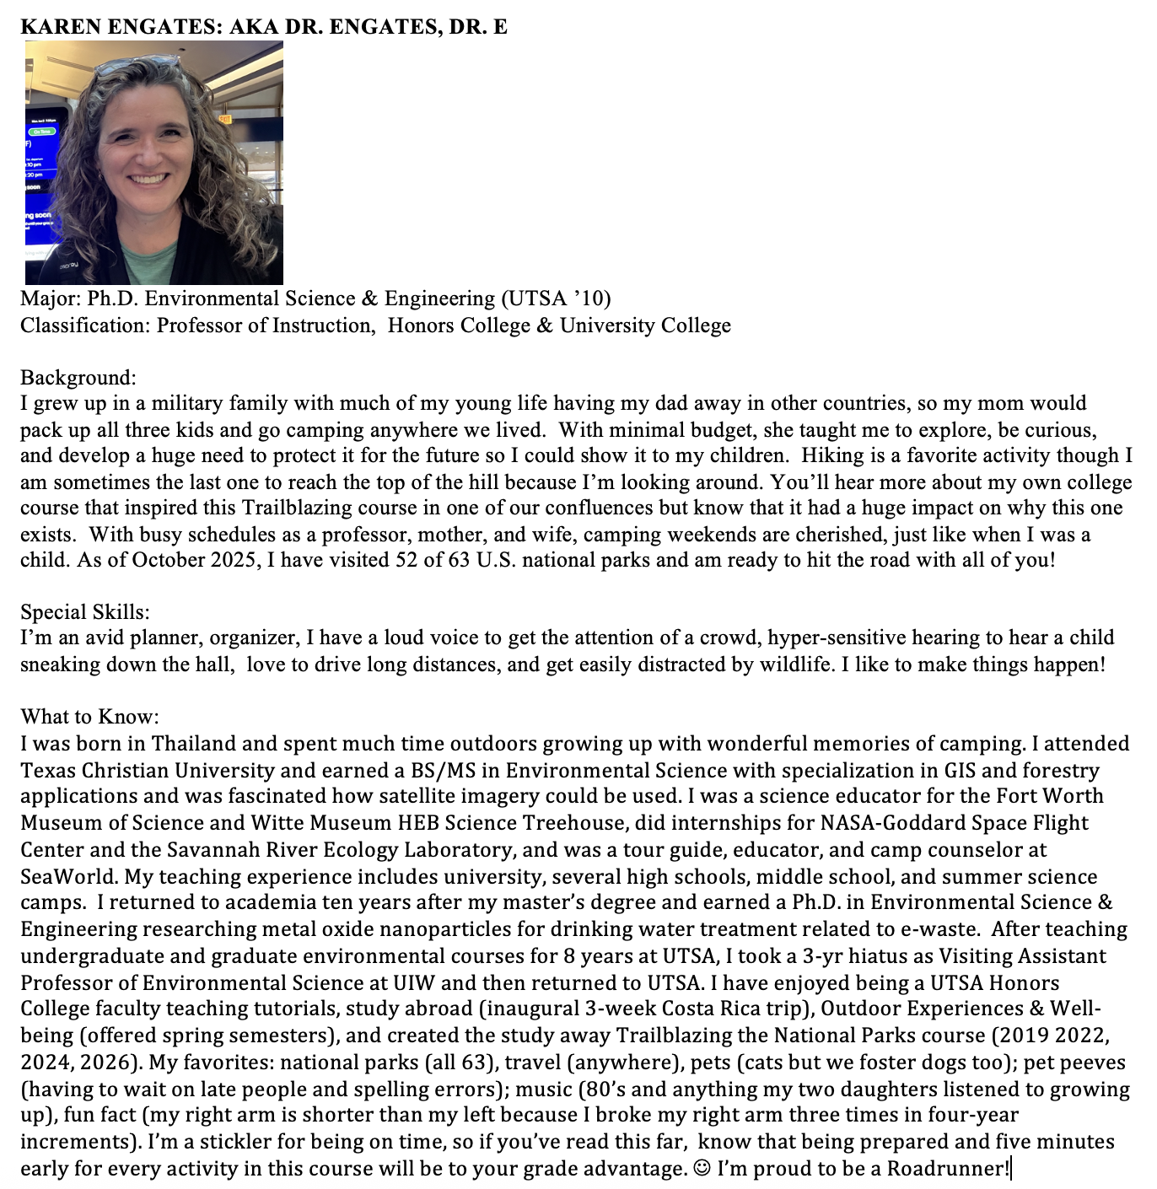

PLEASE CONTINUE TO THE LAST PAGE.

Conditions of Participation
UTSA Honors College Program
HON 3253: Trailblazing the National Parks 2027

You have chosen to be a part of a study-away program provided by UTSA Honors College. This is an educational endeavor with a series of curricular goals to achieve. This is not a vacation. You will be engaged in experiential learning in minimal living conditions and national parks experiences. There is required coursework before leaving and during the trip. It is expected you will read the handbook, follow instructions, actively participate in program activities, and ask instructors for clarification. It is necessary you are respectful, mature, collegial, and considerate to others. Any activity that interferes with the educational endeavor— your learning or that of others—will not be tolerated. Any activity that potentially damages the relationship of UTSA, instructors, United States and Canadian governments, national parks, or our host communities will not be tolerated and will be considered a sanctionable violation that may result in disciplinary action. Failure to comply with conditions listed may have a negative impact on your grade and could result in you being dismissed and returned home at your expense. Examples of non-tolerated behavior include, but are not limited to:

- Academic dishonesty and/or violating the UTSA Code of Student Conduct
- Obstruction or disruption of teaching or other program activities
- Verbal negativity toward the public, instructor(s), participants, program, Honors College, UTSA, governments
- Travel without at least one other student and without explicit approval from the instructor
- Failure to attend daily confluence discussions and unauthorized absences from course activities
- Use/threats of physical violence, sexual misconduct, , profanity, bullying, and/or sexual harassment
- Disrespect, unprofessional behavior toward instructors, students, and other individuals
- Openly abusing community customs and mores and/or violating state/national/international laws
- Damage or destruction of property of others, university, public and private, or cultural sites that we visit.
- No alcoholic beverages are to be brought, purchased, shared, or consumed even if you are of legal drinking age. Evidence of such will result in automatic dismissal from the course.
- Abuse or misuse of alcohol or prescription drugs if their use leads you to do any of the following:
  - Are underage (alcohol) or not the intended patient of prescription medication.
  - Be ill or unable to conduct coursework or miss a scheduled field trip, lecture, or other program event.
  - Are disrespectful, engage in inappropriate or destructive behaviors, disturb others, or disrupt events.
  - Engage in behavior that causes embarrassment to other group members, faculty, or host(s)
  - Engage in risky activities or make decisions that endanger yourself or others.
- Using illegal and/or recreational substances (even if legal in certain states) will result in immediate dismissal.
- Disturbing others at night (to include quiet hours of campgrounds and cabins)
- Bringing unauthorized guests to program facilities, including lodging and clinic/hospital, or activities
  - Family members and friends are not allowed to meet us for any program-related travel, event, or activity.
- No smoking, vaping, or other tobacco-related products allowed.
- Being absent for any scheduled pick-up or departure, except in cases of extreme emergencies (to be verified).
- Engaging in another activity the instructor(s) consider to be a detriment to the overall program purpose.

Your instructors have authority to take actions they deem appropriate to address issues. Breaking rules may result in a verbal warning, alterations of activity involvement, or immediate sanctions depending on situation severity up to and including course dismissal. Action by instructors does not prevent or preclude Student Conduct and Community Standards from also taking appropriate action upon your return to UTSA. Instructors will be unable to assist a student whose actions violate or allegedly violate local laws, regulations, etc., including any actions that lead to incarceration, or other criminal or civil penalties, nor is it their responsibility to do so. A dismissed student will not receive a refund for the program, tuition, fees, or other costs. A dismissed student shall pay costs of immediate transport home and receive a grade of ‘F’.

By signing below, you acknowledge that you have read, understand, and agree to the above paragraphs.

Student* Signature and Printed Name Date
*Student must be 18 years old by first date of travel (July 27, 2027).

